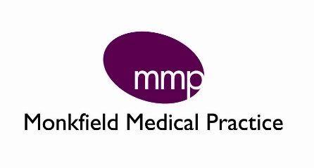
Flu Vaccination
This year the NHS aims for 75% of those of us who are eligible to receive the Flu vaccination, an increase of two thirds on previous years.
This will be challenging due to the impact COVID-19 has had on our all of us, including staff and patients at Monkfield Medical Practice.
It is expected that there will be an increase in the uptake of flu vaccine this year and in addition to this the Government have increased the pool of patient’s eligible for free (NHS funded) vaccination.
In 20/21 groups eligible for the NHS funded flu vaccination programme can be located here: https://www.nhs.uk/conditions/vaccinations/who-should-have-flu-vaccine/
We know that there will be a nationally run recall system, so you will be contacted to inform you that you are eligible. We ask that at this point you DO NOT contact the surgery to request your flu jab.
We have an estimated date of delivery for our vaccines, and will be co-ordinating our approach to ensure at risk groups (such as those who were shielding) are safely prioritised. In order to maintain social distancing, we will be offering appointments when the time comes in a co-ordinated manner to maximise the number of patients we can safely vaccinate.
Please be reassured that we will be putting out further communication on our website and via our Facebook page and contacting you direct when we have a clear plan of action.
https://www.monkfieldpractice.co.uk/
https://www.facebook.com/MonkfieldMedicalPractice/
Thank you for your continued support and understanding whilst we continue to adapt our working practices to ensure you get the service you need while keeping us all safe.
Hannah Crisford, Practice Manager

